Welcome to the 126th
St. Louis Camp Meeting of the Church of God

Saturday, August 3

Sunday All-Camp Potluck

There will be an all-camp potluck immediately following the Sunday morning service (around 12:30 p.m.). Everyone is invited to bring a dish to pass and come fellowship! Hamburgers, hot dogs, bottled water and table service will be provided.

We will also have a Corn Hole double-elimination tournament after lunch (starting about 2:00) on the lawn between the Duplex and the Maintenance Barn. Bring your corn hole set and find a partner…there will be prizes for first, second and third places!

Speakers at a Glance:

Sunday August 4: Herb Banks (Flint, MI)
Monday August 5: Herb Banks (Flint, MI)
Tuesday August 6: Erin Taylor (Alma, MI)
Wednesday August 7: Erin Taylor (Alma, MI)
Thursday August 8: John Davey (Lansing, MI)
Friday August 9: John Davey (Lansing, MI)
The lacing table will not be open on Sunday due to the family activities planned. It will be open Monday through Friday noon to 2 p.m.
This Too, Will Pass

When discouragement comes our way,
And dark and gloomy seems our day;
Then Jesus with comforting words will say:
“This too, will pass. Have faith in me.
I understand and will strengthen thee.”

When we’re sad and feel like crying,
And thing, “What’s the use of trying?”
We hear Jesus’ tender voice sighing;
“This too, will pass. Have faith in me.
I understand and will strengthen thee.”

When we’re ill and wracked with pain,
And do not seem our health to gain’
We hear Jesus say to us again,
“This too, will pass. Have faith in me.
I understand and will strengthen thee.”

When Earth’s sorrows crush us sore,
And it seems we can stand no more.
We hear Jesus saying, as before,
“This too, will pass. Have faith in me.
I understand and will strengthen thee.”

Mary Ruckle
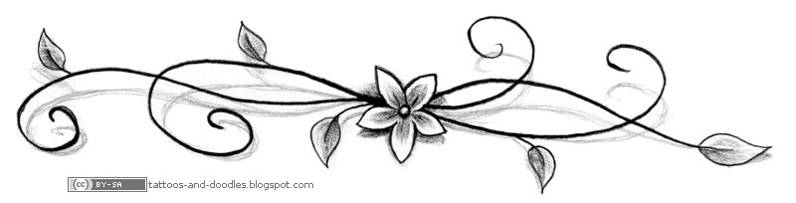

The WCG cottage will be open Sunday between morning and evening services, and then open for ½ hour after evening service.

All ladies: Please plan to attend our Monday Afternoon Delight at 2:00 p.m. We will be having a Thrift Shop Fashion Show!

DID YOU KNOW?
We have an anonymous donor who has issued a challenge to all you folks at camp meeting!
For every 5 donations of $250, this generous donor will give an additional $250 to the campground! Please pray about supporting the St. Louis Campground!

Shankel Septic Service will be providing a honeywagon service this year on Wednesday for $17.50. You can sign up for this service at the registration office.
Tonight’s Senior Adult Gathering will be with Doug Bitler and family. Come join in the fun at the Senior building ½ hour after service tonight!
Steve Gulick brought the message to us last night about the first “RE-“ word: ‘Remember’. We should always remember what God has saved us from. It’s easy to forget the days of living for the world, and not for Jesus. For believers, once we finally put our past behind us, we tend to never want to look back.

All of us have our stories. Some might feel their testimony is not as scandalous as others, but it’s your story. We seem to forget that we all are as much in need of Jesus as a man on death row. Yet, we are quick to judge others as they are dwelling in their sin, thinking “How could they live like that?”

In the Bible, Paul shares that it is by God’s mercy we have been saved. It is God who saved us from our wickedness, and justified his people through his Son. When we realize God’s faithfulness in sparing us from our self-destruction, we see his marvelous grace. When we talk about our prior bondage, we are quick to reflect on God being rich in his mercy. This reminds us of how thankful we should be for the work of the cross.

Let us remember to celebrate the work of the cross. We will always need Jesus, and should always REmember what He saved us from.
If you’re interested in purchasing a memorial plaque for the prayer garden, please stop in at the business office and talk to Sandy Turk. She is always glad for visitors….and to accept your donations on behalf of the campground.
Thank you for your support!
What do you remember most about St. Louis Camp Meeting?
Let’s have a little fun. Fill this paper out with as much or as little as you’d like, and return to the business office. Who knows? We might include your memories in the nightly newsletter!

How long have you been coming to St. Louis Campmeeting? ____________________________________
What’s your earliest memory of camp meeting? _________________________________________________
__________________________________________________________________________________________________
__________________________________________________________________________________________________
Who do you remember from years past? _________________________________________________________
__________________________________________________________________________________________________
__________________________________________________________________________________________________
Did you go to kid’s camp? _______________________________________________________________________
Who was your favorite teacher or youth leader? _________________________________________________
__________________________________________________________________________________________________
Something that no one knows you did at camp meeting: _________________________________________
__________________________________________________________________________________________________
__________________________________________________________________________________________________
__________________________________________________________________________________________________
Do you have any funny stories to share? __________________________________________________________
__________________________________________________________________________________________________
__________________________________________________________________________________________________
__________________________________________________________________________________________________
__________________________________________________________________________________________________
__________________________________________________________________________________________________
__________________________________________________________________________________________________
__________________________________________________________________________________________________
__________________________________________________________________________________________________
__________________________________________________________________________________________________
__________________________________________________________________________________________________

